**Outstanding Service Team Member**

1 Nomination Form/Letter

2 Endorsement Letters

The Thanks Badge II honors a previous Thanks Badge recipient who has continued to provide exemplary service in a leadership role, resulting in a measurable impact that benefits the entire Girl Scout Movement.

Service is above the expectations for the position held and made an impact on one or more service units.

This award is given to volunteers who continue to demonstrate exceptional service, and extraordinary dedication to the Girl Scout Movement for two years or more after receiving the Appreciation Pin. Awarded once in a lifetime.

Outstanding service to a geographic service area by a service team member.





Years of Membership- Total years as a registered member (both girl/adult) at five-year intervals.

**Please Note:** **15 years** and above are presented at the event.

**5 and 10 years** are presented at the Service Unit level.

Years of Membership are **self-nominated**.

Yes

**Commitment to Excellence Award**

1 Nomination Form/Letter

2 Endorsement Letters

Yes

Yes

Service is above the expectations for the position held and made an impact on two or more service units.

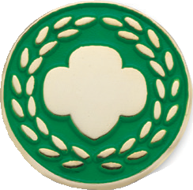

**Honor Pin**

1 Nomination Form/Letter

3 Endorsement Letters

**Thanks Badge**

1 Nomination Form/Letter

4 Endorsement Letters

The Thanks Badge honors an individual whose ongoing commitment, leadership, & service have had an exceptional, measurable impact on meeting the mission delivery goals & priorities of the Council or the entire GS Movement.

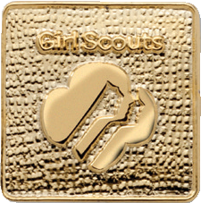

Yes

**Appreciation Pin**

1 Nomination Form/Letter

2 Endorsement Letters

Yes



Yes

**Thanks Badge II**

1 Nomination Form/Letter

4 Endorsement Letters

Exceptional service and commitment to the troop/group, service unit, and/or council within the first or second year of becoming a volunteer.



**GSUSA/GSNNJ AWARDS**

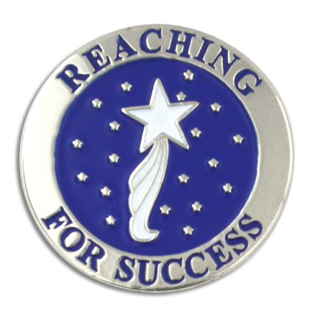



**Rookie of the Year**

1 Nomination Form/Letter

1 Endorsement Letter

Yes

Yes

Outstanding service above the expectation of the position while partnering directly with girls in any pathway to implement the GSLE.

**Volunteer of Excellence**

1 Nomination Form/Letter

1 Endorsement Letter

