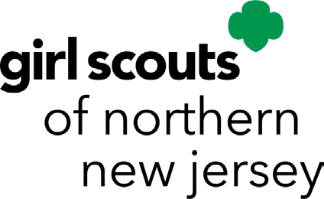
Service Bar Report
For reporting hours towards the
Community Service Bar and/or Service Bar to Girl Scouting Bar
Updated 12/24

Girl Scout Cadette, Senior, and Ambassador Community Service Bar
*See attached list for organizations that are pre-approved. All others follow the procedure below:
Candidates must first obtain permission to begin their service. For approval, each girl must email highestawards@gsnnj.org the following information:
- Name of organization with whom the service will be performed.
- Physical & email address of organization.
- Name, email, and phone number of the contact person you will be working with.
- Description of service to be performed.
Once email approval has been given, the candidate may proceed toward earning the bar.
Cadette, Senior, and Ambassador Service to Girl Scouting Bar
*Prior approval is not required to begin service.
__________________________________________________________________________________________

Upon completion of hours, present this form (with log of hours) at one of our three council shops and purchase the appropriate pin.
Girl Scout Level: Cadette _____________ Senior _____________ Ambassador _________
Bar Earned: Community Service Organization ________________________________________
Council Approval Date: ________________________________
Service to Girl Scouting
Name:________________________________________________________________________________
Service Unit: __________________________________________ Troop No: _____________________
Address: _____________________________________________________________________________________
City: _________________________________________ State: ___________ Zip: _________
Email Address: _________________________________________________________________________________
Supervisor/Advisor Name: _______________________________________________________________________
Supervisor/Advisor Signature: ___________________________________________________________________

Service Bar Time Log
(Minimum 20 hours)

Service Bar Time Log
(Minimum of 20 hours)

Name: ________________________________________________________________________________

Date | Activity or Action | Time Logged  (Hours) | Running Total of Time (Hours)

Reminders:
- All 20 service hours must be in service to the same organization.
- The bar may be earned once per level of Girl Scouting.

Service to the following does not require prior approval:
- Religious organizations

- Non-profit school

- Food bank

- Animal shelter

- Non-profit senior facility

- Public library

- Municipality

- Municipal recreation department

- Homeless shelter

- Nature center

- Mission work

- Safety town

